Government of Islamic Republic of Pakistan

STAKEHOLDER ENGAGEMENT PLAN

(SEP)

KP Citizen-Centered Service Delivery Project
(KP CCSDP)

Federal Ministry of Economic Affairs (MEA)
National Database and Registration Authority (NADRA)

Department of Health (Khyber Pakhtunkhwa)

MARCH 2023

Table of Contents

EXECUTIVE SUMMARY i

1. INTRODUCTION / PROJECT DESCRIPTION 1
1.1. Project Objective 1
1.2. Project Area 1
1.3. Project Components 1
1.4. Project Beneficiaries 2
1.5. Project Duration 2

2. Rationale and Objective of SEP 3

3. Stakeholder Identification and Analysis 4
3.1. Methodology 4
3.2. Stakeholders Identified 4
3.2.1 Affected Parties (APs) 5
3.2.2 Other Interested Parties (OIPs) 5
3.2.3 Disadvantaged/Vulnerable Individuals and Groups 6
3.3. Stakeholders Influence 7

4. Stakeholder Engagement PROGRAM 9
4.1. Project Stakeholder Needs, Methods, and Tools for Engagement 9
4.1.1 Proposed Strategy for Stakeholder Engagement 9
4.1.2 Stakeholder Engagement Needs 10
4.2. Proposed Strategy for Information Disclosure 11
4.3. Summary of Stakeholder Engagement during Project Preparation 12
4.4. Proposed Stakeholder Engagement Plan 16

5. Resources and Responsibilities 19
5.1. Resources 19
5.2. Management Functions and Responsibilities 20

6. Grievance Redress Mechanism 21
6.1. Objectives 21
6.2. Grievance Procedure 22
6.3. Responsiveness to SEA / SH 22
6.4. Disclosure of GRM 23

7. Monitoring and Reporting 24

ANNEXES 25
Annex-1: Pictoral Evidence of Consultation Sessions 25
Annex-2: List of Stakeholders Consulted 28

List of Tables

Table 3-1: Affected Parties 5
Table 3-2: Other Interested Parties 5
Table 3-3: Disadvantaged/Vulnerable Groups or Individuals 6
Table 4-1: Stakeholder Engagement Approaches 9
Table 4-2: Stakeholder Engagement Needs 10
Table 4-3: Stakeholders and Methods for Information Disclosure 11
Table 4-4: Stakeholder Views and Concerns 13
Table 4-5: Implementation Phase Stakeholder Engagement Plan 16
Table 5-1: SEP Implementation Budget 19

Abbreviations
APs | Affected Parties
AD | Auto Disable
CBOs | Community Based Organization
CCSDP | Citizen Centered Service Delivery Project
CFC | Citizen Facilitation Centers
CNICs | Computerized National Identity Cards
CRCs | Child Registration Certificates
CRMS | Civil Registration Management System
CSOs | Civil Society Organization
CWG | Child Wellness Grant
DoH | Department of Health
MEA | Federal Ministry of Economic Affairs
E&S | Environment and Social
ESF | Environmental and Social Framework
ESMP | Environmental and social Management Plan
ESS | Environmental and Social Standard
FGD | Focus Group Discussion
GBV | Gender Based Violence
GoKP | Government of Khyber Pakhtunkhwa
GRM | Grievance Redress Mechanism
GRO | Grievance Redress Officer
HUJRA | Holistic Understanding for Research and Action
ICT | Information and Communication Technology
KP | Khyber Pakhtunkhwa
LG&RDD | Local Government and Rural Development Department
LHO | Lawari Humanitarian Organization
LMP | Labour Management Procedures
MAS  MEA | Merged Areas Secretariat  Ministry of Economic Affairs
MSF | Médecins Sans Frontières
NADRA | National Database and Registration Authority
NBP | National Bank of Pakistan
NGO | Non- governmental Organization
OHS | Occupational Health and Safety
OIPs | Other Interested Parties
OSS | One Stop Shop
P&DD | Planning and Development Department
PADO | Peace and Development Organization
PDMA | Provincial Disaster Management Authority
R&RD | Reconstruction Department
SEA | Sexual Exploitation and Abuse
SH | Sexual Harassment
SEP | Stakeholder Engagement Plan
TDP-ERP | Temporarily Displaced Persons-Emergency Recovery Project
VRS | Vital Registration Services
WB | World Bank

EXECUTIVE SUMMARY

INTRODUCTION

The Government of Pakistan (GoP), the Client, is preparing a project entitled “KP Citizen-Centered Service Delivery Project with proposed support from the World Bank (WB). The proposed Project is being built based on a previous Project entitled Temporarily Displaced Persons-Emergency Recovery Project (TDP-ERP) which is distinctly reflected in its achievement of targets, a year ahead of the project closing.

The project has prepared the present Stakeholder Engagement Plan (SEP) to define the stakeholder engagement and consultation requirements during the various phases of the project, in accordance with the WB Environmental and Social Framework (ESF), in particular ESS10: Stakeholder Engagement and Information Disclosure.

This Stakeholder Engagement Plan (SEP) aims to provide guidance on stakeholder engagement by defining approaches for public consultation and information disclosure through the project lifecycle. It outlines the ways in which the project team will communicate with stakeholders and includes a mechanism by which stakeholders can raise concerns, provide feedback, and make grievances related to project activities.

PROJECT DESCRIPTION

The proposed project will continue to support all existing activities under the TDPERP. Continuation of the project will provide an opportunity to the GoKP to take over the complete program through a phased transition. The same program design and institutional setup will be replicated under the proposed Project with revised results to cover the extended period of support.

Project Components

The proposed Project has two (02) components as briefly described below:

Component 1: Promoting Access to Child Health Services

A selection of child health services are offered to mothers with children aged 0-24 months. The selected services include child health awareness and counselling, screening of children for malnutrition using growth monitoring, immunization services, and referral of complicated cases to pre-identified stabilization centres and pediatricians. To create demand for the visit, the Child Wellness Grant (PKR 12,500 spread over 5 visits) is provided against attendance of health awareness sessions and growth monitoring of the child. The proposed project will cover300,000 additional beneficiaries availing the complete cycle of CWG.

Component 2: Enhanced Citizen Centered Service Delivery and Program Management

This component will provide technical assistance to enhance program management, transparency and accountability at the federal, Provincial and local level administration through capacity building, stakeholder consultation, social mobilization, strategic communication and awareness, and monitoring.

STAKEHOLDER ENGAGEMENT

Stakeholder engagement is a necessary and mandatory requirement for all development projects. To address this requirement, an SEP including a project-level Grievance Redress Mechanism (GRM) needs to be prepared in accordance with Environmental and Social Standard -10 (ESS-10) of the WB ESF, for all WB financed projects. The overall objective of this SEP is to define a program for stakeholder engagement, including public information disclosure and consultations, throughout the entire project cycle. The SEP outlines the ways in which the project team will communicate with stakeholders and includes a mechanism by which people can raise concerns, provide feedback, or make complaints about the project and any activities related to the project.

Stakeholder analysis identifies relationships between the project and potential stakeholders. Stakeholders are defined as individuals, communities, and organizations/institutions that:

- Are impacted or likely to be impacted, either directly or indirectly, positively or negatively, by the project activities. Stakeholders falling under this category are referred to as “Affected Parties” (APs).

- May have an interest in the project and have the potential to influence the project’s outcomes in any way. These are referred to as “Other Interested Parties” (OIPs).

- Are highly vulnerable to potential project impacts and do not have a voice to express concerns or understand the project’s risks and impacts. Aspects of vulnerability may include: gender, ethnicity, religious identity, health conditions, disabilities, economic marginalization, financial and food insecurity, disadvantaged status, and dependence on natural resources. Stakeholders in this category are referred to as “Disadvantaged/Vulnerable Individuals and Groups”.

STAKEHOLDER CONSULTATIONS

Stakeholders consulted during project preparation included representatives from related government departments, including district level staff, NGOs/CBOs/CSOs and private sector companies. These stakeholders were interviewed through face-to-face and virtual group sessions.

The proposed Project is being built on the basis of a previous Project of Temporarily Displaced Persons-Emergency Recovery Project (TDP-ERP), therefore, the consultations session (November 2020) conducted for previous project with relevant stakeholders are also considered, in addition to fresh consultative sessions (March 2023), for this new proposed Project.

RESOURCES

Implementation budget for this SEP will require PKR 25.2 million over the duration of the project (two years), which will come from the proposed Project. This includes all costs related to ongoing engagement with stakeholders, information disclosure, grievance redress, and other activities described in the final SEP.

MANAGEMENT FUNCTIONS AND RESPONSIBILITIES

SEP implementation will be led by the MEA-PMU through NADRA. The Social Specialist and Gender Specialist will be responsible for overall management of SEP activities, and progress reporting through field staff. Field teams at the district level will be responsible for on-ground implementation of the SEP, including conducting consultations, information disclosure, and progress reporting to the MEA-PMU Social and Gender Specialists. Progress updates on SEP implementation will be provided quarterly to the World Bank.

GRIEVANCE REDRESS MECHANISM

A Grievance Redress Mechanism (GRM) has been established by the Project and will remain operational throughout implementation. Grievance redress counters have been established and staffed by NADRA at the One Stop Shop (OSS)/ Citizen Facilitation Center (CFC). NADRA being implementation agency of the program have the responsibility to coordinate with the concerned stakeholders such as Payment Service Providers, District Administration, PDMA and beneficiaries for resolution of grievances related to targeting, payments, quality of services and updating family information, etc. Grievance counters provide a mechanism for social accountability of the Project.

An operational and effective GRM has already in place through NADRA for the FATA-TDP ERP for project related issues. This operational GRM, uses technology-based mechanisms for grievance redress with counters established at all CFCs, will be utilized under the proposed Project to ensure fairness, transparency, and timely responses. This GRM has been prepared at Project level, however, a separate GRM will be prepared for Labor involved in the proposed Project and as a part of Labor Management Procedures.

The GRM includes the following main categories:

- Appeals: These are grievances related to eligibility where a family member has not been included as “Beneficiary” and he/she feels that he/she fulfils the eligibility criteria of the project. Appeals are mainly linked to exclusion in targeting. These will be lodged by NADRA and forwarded to the respective authority for approvals including local/district administration and PDMA.
- Complaints: These include grievances against the system or processes which have been put in place to assist the applicants/beneficiaries but are not functioning properly or catering to the complainants’ needs. These can both include complaints against the enrolment and payment processes, and may also include complaints on behavioral issues, malpractices / bribery etc. All complaints shall be dealt through either telephone (help line) and / or by registering the complaint at the GR counter at the local CFCs. All complaints will be registered in Case Management System (CMS) developed by NADRA.

Grievance Procedure

A Grievance Redress Counter is setup at the CFCs which is operated by representatives of NADRA who act as the Grievance Redress Officer (GRO). All complaints, whether received at the counters or project helpline, are registered in the MIS in the Complaints section. As the applicant approaches the GR counter/helpline, they lodge the complaint and provide their CNIC and name. This allows the complaint to be tracked via the Complaints Management System (CMS), developed, and provided by the Implementing Agency i.e., NADRA. There are no committees linked to the Project GRM; complaints are forwarded directly through the MIS to the relevant stakeholder for further investigation into the nature of the complaint and subsequent resolution.

INTRODUCTION / PROJECT DESCRIPTION

The Government of Pakistan (GoP), the Client, is preparing a “KP Citizen Centered Service Delivery Project (CCSDP)” with proposed support from the World Bank (WB). The proposed Project is being built on the basis of a previous Project of Temporarily Displaced Persons-Emergency Recovery Project (TDP-ERP) which is distinctly reflected in its achievement of targets, a year ahead of the project closing.

The proposed project will continue to support all existing activities under the TDPERP. Continuation of the project will provide an opportunity to the GoKP to take over the complete program through a phased transition while maintaining and consolidating its achievements, preventing the loss of gains due to the limited financing capacity of KP, and expanding the coverage of interventions achieved under the TDPERP. The same program design and institutional setup will be replicated under the proposed Project with revised results to cover the extended period of support.

Project Objective

The project development objective is “to promote access to child health services and enhance citizen-centered service delivery in selected districts of Khyber Pakhtunkhwa Province”. Enhanced citizen-centered service delivery refers to more frequent use of services, an increase in the types of services available, especially ones under the provincial mandate, as well as the transition to management under KP.

Project Area

The proposed project will be implemented in all seven districts of the Newly Merged Areas (erstwhile FATA) and four adjoining districts, namely Bannu, D.I Khan, Lakki Marwat and Tank of KP.

Project Components

The proposed project will facilitate the smooth transition of the program to the province of KP, including bridging the financing gap for the continuity of the activities under the ongoing FATA TDPERP. The follow-up project will provide for a phased transition for the takeover by the KP government of the complete program while maintaining and consolidating its achievements, preventing the loss of gains due to the limited financing capacity of KP, and expanding the coverage of interventions achieved under the TDPERP. The same program design and institutional setup will be replicated under the new project with revised results to cover the expected transition to KP and the extended period of support.

The proposed Project has two (02) components as described below:

Component 1: Promoting Access to Child Health Services

A selection of child health services will be offered to mothers with children aged 0-24 months. The selected services include child health awareness and counseling, screening of children for malnutrition using growth monitoring, immunization services, and referral of complicated cases to pre-identified stabilization centers and pediatricians. To create demand for the visit, the CWG (Rs 12,500 spread over 5 visits) is provided against attendance of health awareness sessions and growth monitoring of the child. Uptake of the immunization services will remain voluntary. This component will be offered to all families with children aged 0-2 years irrespective of whether they are from TDP families. The proposed project will cover 300,000 additional beneficiaries availing the complete cycle of CWG

Component 2: Enhanced Citizen Centered Service Delivery and Program Management

This component will provide technical assistance to enhance citizen centered service delivery and program management, transparency, and accountability at the federal, provincial, and local level administration through capacity building, stakeholder consultation, social mobilization, strategic communication and awareness, and monitoring. In TDPERP NADRA under PMU (based in MEA) supervision, has helped to design a robust system for cash transfers with adequate safeguards, fiduciary oversight, accountability, and transparency paying close attention to data security and protection issues. The expanded CFC services include Vital Registration Services (VRS), Civil Registration Management System (CRMS) and NADRA E-Sahulat platform (an ecommerce and payment services platform). VRS includes all services pertaining to issuance or modification Computerized National Identity Cards and Child Registration Certificates (CRCs). Introduction of CRMS in collaboration with the local government/administrative offices enable citizens, particularly women, to receive birth certificates, marriage certificates, and death certificates. The 40 existing CFCs as well as the 3 new CFCs to be established through this component ensure a plug and play platform for public service provision which the district governments are currently challenged to provide in NMDs. Through the adoption of this model in other settled districts as an administrative tool, service delivery efficiencies can be further enhanced. The proposed project will continue to strengthen program management and oversight as well as extend additional services.

Project Beneficiaries

The project is expected to potentially provide support to 860,000 beneficiaries living in the seven 7 NMDs and four 4 adjacent districts of Khyber Pakhtunkhwa. Nearly 300,000 families with children would benefit from the Child Wellness Package and 560,000 will be utilizing other services provided at the CFC. The KP government will own 43 fully functional CFCs where additional provincial services can be introduced including but not limited to SP as a follow through of the recommendations of the recently approved KP Social Protection Policy.

Project Duration

The proposed Project will be implemented over a period of 2 years.

Rationale and Objective of SEP

The proposed Project has been prepared under the World Bank’s Environmental and Social Framework (ESF). Through the Environmental and Social Standard 10 (ESS10: Stakeholder Engagement and Information Disclosure), the ESF requires the timely, relevant, understandable, and accessible disclosure of project information in a way that is free of manipulation, interference, coercion, discrimination, and intimidation.

ESS10 recognizes the importance of open and transparent engagement between the Borrower and project stakeholders as an essential element of good international practice. Effective stakeholder engagement can improve the environmental and social sustainability of projects, enhance project acceptance, and make a significant contribution to successful project design and implementation. Stakeholder engagement is an inclusive process conducted throughout the project lifecycle. When properly designed and implemented, it supports the development of strong, constructive, and responsive relationships that are important for successful management of a project’s environmental and social risks.

This Stakeholder Engagement Plan (SEP) aims to provide guidance on stakeholder engagement by defining approaches for public consultation and information disclosure throughout the project lifecycle. It outlines the ways in which the project team will communicate with stakeholders and includes a mechanism by which stakeholders can raise concerns, provide feedback, and make grievances related to project activities. It does this by:

- Establishing a systematic approach to stakeholder engagement that will help Borrowers identify stakeholders and build a constructive relationship with them, particularly with project Affected Parties (APs)
- Assessing the level of stakeholder interest and support for the project, and to enable stakeholder views to be considered in project design and environment and social performance
- Promoting and providing means for effective, inclusive engagement with project APs throughout the project lifecycle
- Ensuring that appropriate project information on environmental and social risks and impacts is disclosed to stakeholders in a timely, understandable, accessible, and appropriate manner.

Stakeholder Identification and Analysis

Stakeholder analysis identifies relationships between the project and potential stakeholders. Stakeholders are defined as individuals, communities, and organizations/institutions that:

- Are impacted or likely to be impacted, either directly or indirectly, positively or negatively, by the project activities. Stakeholders falling under this category are referred to as “Affected Parties” (APs).

- May have an interest in the project and have the potential to influence the project’s outcomes in any way. These are referred to as “Other Interested Parties” (OIPs).

- Are highly vulnerable to potential project impacts and do not have a voice to express concerns or understand the project’s risks and impacts. Aspects of vulnerability may include gender, ethnicity, religious identity, health conditions, disabilities, economic marginalization, financial and food insecurity, disadvantaged status, and dependence on natural resources. Stakeholders in this category are referred to as “Disadvantaged/Vulnerable Individuals and Groups”.

Methodology
The method of consultation with stakeholders can play a significant part in ensuring comprehensive, inclusive engagement. It is therefore important to identify the most appropriate consultation modes for each stakeholder. The project will apply the following principles for stakeholder engagement:

- Openness and lifecycle approach: public consultations for the project will continue throughout its duration and will be free from manipulation, coercion, and intimidation.

- Informed participation and feedback: project information will be widely distributed amongst all stakeholders using appropriate formats, languages, etc. Consultations will aim to provide the most up-to-date project information for stakeholder feedback. Opportunities will be provided for stakeholders to raise concerns, and processes will be built in to ensure that stakeholder feedback is taken into consideration during decision making.

- Inclusiveness and sensitivity: participation in stakeholder consultations will be inclusive, and all stakeholders will be encouraged to be involved. All stakeholders will have equal access to information, and special care will be taken to ensure the project is sensitive to the needs of all stakeholders, including vulnerable groups.

Stakeholders Identified
The project’s stakeholders can be categorized as follows:

- Affected parties;
- Other interested parties; and
- Disadvantaged/vulnerable individuals or groups.

Affected Parties (APs)

Affected Parties are the stakeholders that are likely to be affected by the project because of actual impacts or potential risks to their physical environment, health, security, cultural practices, well-being, or livelihoods. In the context of this project, these include provincial government departments, health workers, and communities residing in the project areas. The APs identified for this project are provided in Table 3-1.

Table 3-1: Affected Parties
Sectors | Stakeholders
Community | Local Community members including pregnant and lactating mothers, children of 0-2 years and their parents
 | Communities living in proximity of the CFCs
 | Community representatives (elected)
 | Tribal elders and local religious leaders (Imam)
Private Sector | Contractors for rehabilitation works
 | Other service providers (e.g., transporters)
Government/Institutions | Local/ District Administration
 | Department of Health (DoH)
 | Health Care Workers
 | The National Bank of Pakistan

Other Interested Parties (OIPs)

Other interested parties are those stakeholders (individuals, groups, or organizations) with an interest in the project, which may be because of the project location, its characteristics, its impacts, or matters related to public interest. For example, these may include regulators, government officials, the private sector, the scientific community, academics, unions, women’s organizations, other civil society organizations, and cultural groups.

In the context of the project, OIPs include provincial government departments, universities and academia, and local and international NGOs and CSOs working and other value chain stakeholders. Though these stakeholders are not directly involved in the project activities, they may have sector specific experience and knowledge that can assist informed decision making for the project.
The following OIPs have been identified for this project provided in Table 3-2.

Table 3-2: Other Interested Parties
Sector | Stakeholders
Government/Institutional | Directorate of Projects under the Merged Areas Secretariat (MAS)
 | KP Planning and Development Department (P&DD)
 | Local / District Administration of target districts
 | Provincial Disaster Management Authority (PDMA)
 | Academic institutions such as Centre for Public Policy Research at the Institute of Management Sciences, Peshawar
 | Social Welfare Department, KP
 | Environmental Protection Agency, KP
Other donor funded projects | Livelihood Support & Community Infrastructure Project
NGOs/CBOs/CSOs/Private Sector | National Rural Support Program (NRSP)
 | MSF (Médecins Sans Frontières)
 | Sarhad Rural Support Program (SRSP)
 | Other non-profits working in the area (Hayat Foundation, Asia Humanitarian Organization, HUJRA, Al-Raees, PADO, PAIMAN Alumni Trust)
 | LHO (Lawari Humanitarian Organization)
 | PEACE Organization
 | Khwendo Kor
 | SABWON
 | Lasoona
 | SAHARA

Disadvantaged/Vulnerable Individuals and Groups

This category includes stakeholders who may be more likely to be adversely affected by the project impacts and may be more limited than others in their ability to take advantage of a project’s benefits. Such stakeholders are also more likely to be excluded from, or unable to fully participate in the consultation process, and may require specific measures and/or assistance to do so.

Their vulnerability may stem from ethnic or religious backgrounds, gender, age, health, disability, economic deficiency/financial insecurity, disadvantaged status in the community (e.g., ethnic and religious minority groups, indigenous peoples, women and girls, etc.) and dependence on other individuals or natural resources. For instance, for persons with disabilities (PWD), ease of access may be addressed through the provision of wheelchairs and ramps at the CFCs.

It is important to ensure that these stakeholders can safely and openly participate in the consultation process, and care must be taken to consider their sensitivities and cultural differences to ensure that they fully understand the project activities, risks, and benefits. Some examples of Disadvantaged/Vulnerable Groups or Individuals are provided in Table 3-3.

Table 3-3: Disadvantaged/Vulnerable Groups or Individuals
Sector | Stakeholders
Government | Female staff  (involved in Project)
Community | Female/child headed households
 | Women (especially in the NMDs)
 | Internally Displaced Persons (IDPs)
 | Refugees (for instance Afghan refugees)
 | Ethnic and religious minorities
 | Persons with disabilities
 | Transgender communities
 | Senior citizens
 | Citizens without CNIC
 | People with low / no literacy levels
 | Economically marginalized groups including household below poverty line

Stakeholders Influence

The proposed project is the continuation of an existing program (TDP ERP) with essentially a reduced scope. Therefore, the approach for stakeholder engagement has also been kept aligned with the TDP ERP project, because that one remained successful as evident from the social acceptability enjoyed by the project despite challenging political and social frame conditions. The approach for the stakeholder engagement analysis has been underscored by three elements: belief in the primacy of qualitative data, commitment to participatory methods and flexible responsive methods. Preliminary identification and analysis of the different stakeholders and their potential roles have been based primarily on the experience of the TDP ERP, discussions with project management, and feedback from development practitioners working in the area.

In general, engagement is directly proportional to impact and influence of a stakeholder. As the extent of impact of a project on a stakeholder group increases, or the extent of influence of a particular stakeholder on a project increases, engagement with that stakeholder group should intensify and deepen in terms of the frequency and the intensity of the engagement method used.

In the typical situation of the project area, many government departments including the security forces remain major stakeholders, whereas the PAPs also remain major stakeholders but with low influence to change the course of the project. The different combinations of influence and importance that a stakeholder may exercise are elucidated in the diagram below which illustrates the degree of importance and influence exercised by the stakeholders. This formulation is based on a limited number of consultations (FGDs) and individual interviews with representatives from the few organizations, which have been consulted to date. The combinations of importance and influence may be updated as more interviews and group consultations are conducted through the project cycle.

DEGREE OF INFLUENCE

High influence Low influence
DEGREE OF IMPORTANCE  Low Importance High Importance | Box A: Stakeholders who stand to lose or gain significantly from the project AND whose actions can affect the project’s ability to meet its objectives  - Department of Health, KP  - Directorate of Projects under the Merged Areas Secretariat (MAS)  - Health Care Workers  - CFC staff in the Project (specially female staff)  - Provincial Disaster Management Authority (PDMA) | Box B: Stakeholders who stand to lose or gain significantly from the project BUT whose actions cannot affect the project’s ability to meet its objectives  - Community representatives and tribal elders (Local Malik)  - Community members including lactating and pregnant mothers, children of 0-2 years and their parents  - Communities living near the CFCs  - Female/child headed households, Refugees, Ethnic and religious minorities, PWDs, Transgender communities, Senior citizens, Citizens without CNIC, Economically marginalized groups
 | Box C: Stakeholders whose actions can affect the project’s ability to meet its objectives BUT who do not stand to lose or gain much from the project  - Local/District Administration  - Social Welfare Department, KP  - Environmental Protection Agency, KP  - Planning and Development Department (P&DD)  - Provincial and federal security forces responsible to maintain law and order in the project area | Box D: Stakeholders who do not stand to lose or gain much from the project AND whose actions cannot affect the project’s ability to meet its objectives  - Federal Environmental Protection Agency  - NGOs (MM Pakistan, Holistic Understanding for Research and Action (HUJRA), SABAWON, Al-Raees Foundation, Lasoona, SAHARA)  - Academic institutions such as Centre for Public Policy Research at the Institute of Management Sciences, Peshawar
The names in black font are those already consulted, while the names in red font are the ones yet to be consulted.

Stakeholder Engagement PROGRAM

Project Stakeholder Needs, Methods, and Tools for Engagement
The Project has been designed to reflect and incorporate the findings from stakeholder consultations during project preparation and implementation. It will rely heavily on continuous stakeholder engagement and feedback throughout its duration.

Proposed Strategy for Stakeholder Engagement

Strong citizen and community engagement are preconditions for the effectiveness of the project. Accordingly, different tools, techniques, and methods will be used for engagement to cover the different needs of stakeholders. The strategy for stakeholder engagement is heavily focused on on-going information disclosure and dissemination that is efficient, transparent, and addresses the needs of different stakeholders. Stakeholder engagement activities will consider the additional threat posed by the COVID-19 pandemic and associated risks. The design and means of stakeholder engagement will be adapted to the current government mandated social distancing requirements and based heavily on electronic and virtual modalities where possible. The implementing entities will work on ensuring that virtually disseminated information is in line with the standards of information sharing pre-COVID-19.

The project will take special measures to ensure that disadvantaged and vulnerable groups have equal opportunities to access information, provide feedback, or submit grievances. Civil society organizations, including NGOs working in the Project Area will also be consulted in this connection. For consultations with communities, and vulnerable individuals and groups that must take place in person, a precautionary approach will be taken to prevent infection and/or contagion, given the highly infectious nature of COVID-19. Table 4-1 summarize the stakeholder engagement approaches.

Table 4-1: Stakeholder Engagement Approaches
Engagement approach | Application of Approach
Correspondence (phone, emails, virtual and face-to-face meetings) | Sharing project information with government officials, NGOs, and other individuals/organizations
Focus group meetings and individual interviews | Presenting project information and receiving feedback, concerns, and suggestions from all stakeholders.
Public meetings | Presenting project information and receiving feedback, concerns, and suggestions from all stakeholders
Project website | Presenting project information and progress updates, disclosing ESMP, and other relevant project documentation to the general public
Visibility/signage | Presenting project information, particularly for awareness amongst potential beneficiaries in the project areas.
Leaflets | Presenting project information and progress updates.
Mobile phones (robo-calls, SMS, social media) | Sharing information on project activities
Mass media (TV, radio, print and electronic media) | Presenting project information and progress updates to the general public.
Beneficiary feedback surveys | For affected parties to provide ongoing feedback throughout the duration of the project

Stakeholder Engagement Needs

The following Table 4-2 lists the key stakeholder categories and identifies their specific needs for engagement.
Table 4-2: Stakeholder Engagement Needs
Stakeholder Type | Characteristics | Language Needs | Specific Needs
Government departments | These include Department of Health, Provincial Government, local administration and PDMA | No specific needs as English and Urdu are both used as working languages in government. | Engagements should be via phone, email, virtual meetings, in-person meetings and workshops (if possible)
Lactating and pregnant women; parents of 0-2 years children | These are the direct beneficiaries of the project | Pushto (most preferred) and Seraiki (for DI Khan and adjoining areas) | Strictly a female-to-female correspondence whereby no male member from the project side tries to contact any female beneficiaries directly
Communities living nearby the CFCs | These maybe directly impacted due to increased traffic, project related emissions, and / or security threats | Pushto (most preferred) and Seraiki (for DI Khan and adjoining areas) | Small group awareness sessions and engagement with local elders are appropriate
Government/institutional OIPs | Stakeholders not directly involved in or affected by project activities may be consulted for technical support or collaboration during the proposed project's implementation. | For national level institutions/groups, Urdu is appropriate.  For district level institutions, engagement should be conducted in local languages (Pashto, Urdu, Seraiki). | Correspondence via email and phone, and in-person individual or small group interviews/meetings are appropriate.
Disadvantaged/vulnerable individuals | These are women (especially in the NMDs), Internally Displaced Persons (IDPs), ethnic minorities, differently abled and transgender communities | Engagement should be conducted in local languages (Pashto, Urdu, Seraiki). | Engagement should be conducted in a culturally appropriate manner.  Female interviewers/ facilitators should be employed when respondents are also female.  Interviews should be conducted at CFCs during regular working hours. Interviewees should not be obliged to travel. Physical accessibility requirements of interviewees should be considered before organizing interviews.  When possible, engagements should be timed to avoid disruption of livelihood activities.  Participants should be given the option to be interviewed at home or via phone when possible, particularly for persons with disabilities.  Awareness raising through appropriate signage, leaflets, mobile phone, and mass media.  Face-to-face interviews should be preferred when possible, as telecommunication access can vary significantly between stakeholders.  Supplemental engagement through project website, GRM.
Illiterate Persons | Individuals or groups directly or indirectly engaged who are illiterate | Consultations with these groups should be held in local languages | Outreach, awareness raising, and capacity building activities involving this group should be sensitive to their literacy needs.  Engagement should be face-to-face when possible.  Awareness raising should not require literacy, preference to be given to voice phone calls, visual media (e.g. posters with simplified, intuitive graphics, video clips, etc.).

Proposed Strategy for Information Disclosure

Information disclosure will follow the World Bank disclosure protocol. The table below provides an initial outline of the information to be disclosed during the project. This list is likely to grow as the SEP is updated during project implementation provided in Table 4-3.

Table 4-3: Stakeholders and Methods for Information Disclosure
Project Stage | Target Stakeholders | Information to be Disclosed | Methods Proposed
Implementation | MEA-PMU/NADRA, APs, OIPs | Project description and E&S impacts, SEP, ESMP, SEA/SH, LMP  Location | One-on-one or group meetings, FGDs,  NADRA website/newsletter  Print, electronic, and broadcast media
Implementation | MEA-PMU/NADRA, and other government APs | Project description and E&S impacts, E&S principles and implementation arrangements, SEP, ESMP, GRM procedures | One-on-one or group meetings, correspondence, training workshops  Leaflets, reports, and brochures
 | Potential project beneficiaries, vulnerable groups | Project benefits and E&S impacts, guidance on receiving benefits, progress updates, SEP, ESMP, GRM, GBV mechanisms. | Outreach through local community Tribal elders, and religious leadership.  Community information sessions/workshops  Public notices/signage  Print, electronic, and broadcast media  Social media
 | Government OIPs | Project overview, project benefits and E&S impacts, progress updates, SEP, ESMP, GRM, GBV mechanisms | One-on-one or group meetings, correspondence, training workshops  Leaflets, reports, and brochures
 | NGOs, CSOs with mandates related to the project | Project overview, project benefits and E&S impacts, progress updates, SEP, ESMP, GRM, GBV mechanisms | MEA-PMU/NADRA website/project website  Print, electronic, broadcast, and social media
 | General public | Project overview, project benefits and E&S impacts, progress updates, SEP, ESMP, GRM, GBV mechanisms | MEA-PMU/NADRA website/project website  Print, electronic, broadcast, and social media

Summary of Stakeholder Engagement during Project Preparation

Stakeholders consulted during project preparation included representatives from related government departments, including district level staff, NGOs/CBOs/CSOs, private sector companies. These stakeholders were interviewed through face-to-face and virtual group sessions.

The proposed Project is essentially the continuation of a previous Project of Temporarily Displaced Persons-Emergency Recovery Project (TDP-ERP). The design of KP CCSDP, therefore, considered the feedback received from the stakeholders during the previous project. In addition to fresh consultation sessions (March 2023) for this new proposed Project, an FGD was previously conducted in DI Khan in November 2020 also, while planning a CFC in that area. A list of stakeholders consulted, and summary of their feedback is provided in Table 4-4 below:

Consultations were carried out with all stakeholders to ensure better service delivery to all the beneficiaries in general and vulnerable groups (female and disables), in particular. Additional stakeholders will be consulted during the project’s implementation, and this SEP shall be updated accordingly as provided in Table 4-4.

Table 4-4: Stakeholder Views and Concerns
Date | Stakeholders | Stakeholder Views/Concerns
4th November, 2020 | District Administration, Health Department, Public & Private Agencies Location: District DI Khan | - A positive impact of the program was anticipated by all the participants including stakeholders and district administration representatives regarding the program intervention in southern districts.  - Participants expressed the view that separate waiting areas and washroom facilities be provided to female visitors at CFCs/OSSs, that efforts be made to coordinate with a nutrition program operational in DI Khan district, and that safe disposal of medical waste should be ensured.
10th November, 2020 | TDP-ERP stakeholders i.e. representatives of MEA, NADRA, DoH (KP) and PDMA, representatives of local elders, LHVs, district administration, Environment Department, Social Welfare Department, MM Pakistan.  Location: District Bannu | - The program service delivery mechanism, target audience, previous achievements in merged area districts and future intervention of the program were highlighted and discussed.  - The participants shared positive feedback regarding the program initiation in southern districts and anticipated a positive and sustainable social and environmental effect in the region.
20th March, 2023 | TDP-ERP stakeholders i.e. representatives of MEA, NADRA, NGOS/CBOs/CSOs (MM Pakistan and HUJRA), DoH (KP), Local Health Staff, and PDMA.  Location: District Bannu | - It was highlighted by a few participants that the provisioning of female staff at CFCs at all times have contributed immensely in gaining the trust of local families, where the turnover of female beneficiaries has increased considerably.  - Representative of local/district administration stated that the program has been largely accepted by the local masses and has been quite successful in creating awareness among local population regarding children and mother’s health. Also, the beneficiaries, local NGOs and the district administration encouraged the successful provisioning and administering of vaccines followed by safe disposal of medical waste.  - Following to the inclusion of CNIC registration service at all CFCs, have resulted a considerable increase towards female CNIC registration, subsequently contributing to an increase in female CWG processing which more than 90% now. Also, it was commended by the forum that due to successfully inclusion of females (54%) through appeals for Livelihood Support Program has led to the financial inclusion of female beneficiaries and have subsequently contributed towards the women empowerment factor.  - All the participants shared positive feedback regarding the program intervention in southern districts of Khyber Pukthunkhwa province and expressed a positive and sustainable environmental and social effect in the region.
20th March, 2023 | Health staff deputed at CFCs  Location: District North Waziristan | - Previously waste was disposed of in normal conventional pits made inside the facility but after the establishment of CFC’s all the pits were made cemented due to which chances of contamination are nil. Department of health (GoKP) has also encouraged this activity and discussions are carried out at higher level to make all the pits cemented all over the KP.  - It was also surfaced by the health staff that previously normal bins were used, whereas recently colour coded paddle bins have been placed at all CFCs which will further contribute towards minimizing the anticipated infections.  - While discussing the issues related to cold chain, it was communicated by the health staff that regular recording of the log/temperature as well as number of vaccines usage/number of beneficiary vaccinated is carried out, while vaccine expiry is also strictly checked prior to issuing/administering the vaccines.  - It was highlighted that main store at DHO office is aware about the vaccine expiry as the check & balance mechanism in place is very efficient.  - Few questions regarding staff attitude, key messages in Health Awareness Sessions (HAS) and its impact on life were asked by the male/female beneficiaries. It was observed that, female beneficiaries were quite satisfied with the services available at CFC’s.
20th March, 2023 | MEA-PMU, NADRA, Department of Health GoKP  Site Incharge- CFC Dogra.  Location: Islamabad | - The grievance process was highlighted and discussed in detail with all the participants, and it was concluded that the grievance system in place have served a large volume efficiently.  - TDP-ERP Helpline mechanism was discussed in detail, where the functionality and efficacy of the system was praised. It has separate female Pushto speakers, to cater the beneficiaries’ queries and complaints.  - It was highlighted and discussed that adequate number of female staff at all CFCs has helped in encouraging female beneficiates to visit the CFCs and get their benefit in secure environment, as separate waiting areas and washrooms being considered as a basic need for project beneficiaries are made available at all functional CFCs.  - The provisioning of lady searchers has further enhanced the turnover of female beneficiaries without being accompanied by male member of the family in a male dominated society.  - Lessons learnt from the previous project (TDP-ERP) and integration of key findings into the updated ESMP designed for the proposed project (KP CCSDP) was also discussed.
24th March, 2023 | MEA-PMU, NADRA, Local/District Administration, NGOS/CBOs/CSOs (Sabawoon, Al-Raees Foundation, Lasoona, SAHARA), DoH (KP), Department of Health- GoKP, and PDMA- GoKP  Location: District Bannu | The following points were highlighted and discussed:  - The designed CFC model leverages a single case management system, information dissemination mechanism (including digital and telecommunication channels), mobilization campaign and grievance management system, to optimize delivery of multiple services at a secure and safe location, reducing costs for the service delivery agencies, beneficiaries and the government itself.  - Existing service delivery channels remain largely unaffected, with the project filling capacity gaps where needed.  - The success of the project has led to a transition from emergency program to a regular development approach, with the successful and commended experiment of the CFCs in the merged and southern districts of KP, the project has demonstrated that this model promises substantial gains on citizen satisfaction, reduced corruption and greater efficiency.  - The availability of adequate number of female staff and provisioning of separate waiting areas and washrooms being considered as a basic need at all CFCs has been catalytic in enhancing the turnover of female beneficiaries at CFCs and obtaining the program benefit in a secure environment.  - The provisioning of lady searchers at CFCs has further contributed in gaining the trust of local female population, where female beneficiaries are visiting the CFCs without being accompanied by family members in a male dominated society.  - The waste management procedures, the current practice i.e. pit burning was highlighted and discussed. The forum was informed regarding the provisioning of cemented pits at all operational CFCs, where all sort of waste is completely burnt whereas the pits are properly closed with lids.  - The representatives from Department of Health (GoKP) informed the forum regarding the mandatory use of WHO pre-qualified Auto-Disable (AD) syringes for administering vaccines, while provisioning of information posters have been ensured regarding needle exchange places indicating safe handling, collection of sharp waste generated during the immunization is discarded in dedicated safety boxes for safe disposal and color coded bins have been made available at all CFCs. Proper monitoring of waste handling, storage and disposal is being carried out to ensure proper implementation of waste management system;  - Development of awareness material conducting trainings of the project staff and district health authorities including facilities staff, healthcare extension workers in hospital waste management as per their roles and responsibilities is being carried out and is updated at regular intervals.
31st March 2023 | Khyber Pakhtunkhwa Environmental Protection Agency and Department of Health  Location: Peshawar | - During the preparation of Environmental Assessment Study, respect the relevant sections of Khyber Pakhtunkhwa Environmental Protection Agency and WHO guidelines;  - It was suggested that the location of burning pits should be away from residential areas;  - Waste Management at all CFCs should be in line with steps provided in the Hospital Waste Management Rules 2005;  - Current practices, particular in Merged Areas, adopted for health care waste management was also discussed.  Training and awareness sessions for the workers and communities should be carried out for effective management of environmental and social aspects.

Pictorial evidence and list of stakeholders consulted are provided in Annex-1 and 2 respectively.

Proposed Stakeholder Engagement Plan

Stakeholder engagement for the proposed Project will be carried out during the implementation phase based on ongoing activities.

Table 4-5 below provides an overview of stakeholder engagement carried out during implementation phase. The SEP will be updated with more specific details on consultations required for the implementation phase.

Table 4-5: Implementation Phase Stakeholder Engagement Plan
Stakeholder Type | Stakeholder | Topics Of Engagement | Engagement Method | Location/Frequency | Responsibility
Affected party | MEA-PMU, NADRA, PDMA | Progress updates, beneficiary targeting, implementation of ESMP and other E&S documents, E&S issues identified during project implementation, LMP and OHS plans | Workshops, in-person and virtual meetings, | Quarterly for first year and bi-annually for next year | MEA-PMU, NADRA, DoH through E&S Specialist/Focal Persons.
 | Local Communities including Tribal Elders and Imam masjid (influential persons) | Awareness raising of project benefits, guidance on how to participate in project, feedback, progress updates, disclosure of ESMP and related E&S documents (where applicable), grievance redress procedure, Working conditions | FGDs, mass media, mobile phone, feedback surveys | Awareness raising campaigns continuously throughout project via mass media, advertisements.  FGD informational sessions and feedback surveys at all Project locations / location agreed with communities representatives | MEA-PMU, NADRA, DoH through E&S Specialist/Focal Persons.
 | Health Care staff, and other workers involved in project implementation including labor | Awareness raising of project benefits, guidance on how to participate in project, feedback, progress updates, disclosure of final ESMP and related E&S documents, grievance redress procedure, LMP and OHS plans, Working conditions | FGDs, mass media, mobile phone, feedback surveys | Awareness raising campaigns continuously throughout project via mass media, advertisements.  FGD informational sessions and feedback surveys at all Project locations, throughout project implementation/Quarterly basis | MEA-PMU, NADRA, DoH through E&S Specialist/Focal Persons.
 | Women’s staff including labor and other women involved in project implementation | Awareness raising of project benefits, guidance on how to participate, disclosure of ESMP and related E&S documents, grievance redress procedure, familiarization with Gender Mainstreaming and GBV, SH, and SEA Action Framework, LMP and OHS plans | FGDs (women only), mass media, mobile phone, feedback surveys | Awareness raising campaigns continuously throughout project via mass media, advertisements.  FGD informational sessions and feedback surveys at all project locations, throughout project implementation/ Quarterly basis | MEA-PMU, NADRA, DoH through E&S Specialist/Focal Persons.
Other interested parties | Directorate of Projects under the Merged Areas Secretariat (MAS), Academic institutions such as Centre for Public Policy Research at the Institute of Management Sciences, Peshawar, Social Welfare Department, KP and Environmental Protection Agency, KP | Project updates, feedback on implemented activities, feedback on proposed activities, actual and potential E&S risks and mitigation measures, LMP and OHS plans | One-on-one and group discussions, correspondence | Quarterly throughout implementation | MEA-PMU, NADRA, DoH through E&S Specialist/Focal Persons.
 | NGOs/CBOs/CSOs/Private Sector | Project updates, feedback on project activities, GRM, disclosure of ESMP and related E&S documents, LMP and OHS plans | One-on-one and group discussions, correspondence | Quarterly throughout implementation | MEA-PMU, NADRA, DoH through E&S Specialist/Focal Persons.
Disadvantaged/Vulnerable individuals and groups | Women (especially in the NMDs), Internally Displaced Persons (IDPs), female-headed households (in some instances child headed households, refugees (for instance Afghan refugees), or disadvantaged groups (ethnic minorities, differently abled and transgender communities), youth, and senior citizens. | Awareness of project benefits, awareness of Gender Mainstreaming and GBV, SH, and SEA Action Framework and GRM, project updates, feedback on project activities, Working conditions | FGDs, in-persons interviews/meetings | At every project location, throughout project implementation/ Quarterly basis | MEA-PMU, NADRA, DoH through E&S Specialist/Focal Persons.

Resources and Responsibilities

Resources

Implementation budget for this SEP will require PKR 25.2 million over the duration of the project (two years), which will come from the proposed Project. This includes all costs related to ongoing engagement with stakeholders, information disclosure, grievance redress, and other activities described in the final SEP.

An estimated budget for implementing the SEP is provided below in Table 5-1.

Table 5-1: SEP Implementation Budget
Item | Quantity | Unit Rate | Total Cost (PKR) | Remarks
Stakeholder engagement events (workshops, meetings, etc.) | 6 | 500,000 | 3,000,000 | Quarterly for first year and bi-annually for next year  (Project Duration is two years)  Covers all organized events for mass stakeholder engagement, and includes location costs, technical services, catering, materials, etc.
Capacity building for citizen engagement and delivery and support to public awareness campaign (trainings, workshops for local focal points and other concerned CFCs staff, masjid imam and tribal elders local government staff) | 4 | 500,000 | 2,000,000 | Bi-annual basis
Community consultations | Lump sum |  | 2,000,000 | All stakeholder engagement carried out with communities in the field, throughout the project life as required
Mass communications campaigns | Lump sum |  | 3,000,000 | For awareness raising campaigns. Includes ad-space costs, printing, technical development of materials, etc.
SEP training activities | Lump sum |  | 2,000,000 | Related to training provided to project teams on SEP implementation, including GRM training.
Social/Gender Specialist | 24 (months) | 300,000 | 7,200,000 | Specialist for implementing the SEP.  This cost has already been considered in ESMP, so it may be managed accordingly.
Communications firm | Lump sum |  | 3,000,000 | Procurement of consultancy services for management of communications campaigns
Travel costs | Lump sum |  | 2,000,000 | For traveling of staff involved in implementing the SEP
Miscellaneous costs | Lump sum |  | 1,000,000 | Other miscellaneous or unplanned costs
TOTAL |  |  | 25,200,000

Management Functions and Responsibilities

SEP implementation will be led by the /MEA- PMU through NADRA. The E&S Specialists will be responsible for overall management of SEP activities, and progress reporting through field staff. Field teams at the district level will be responsible for on-ground implementation of the SEP, including conducting consultations, information disclosure, and progress reporting to the MEA-PMU E&S Specialists. Moreover, GRM Focal Points will be responsible for the implementation of GRM of the Project

Progress updates on SEP implementation will be provided quarterly to the World Bank.

Grievance Redress Mechanism

An operational and effective Grievance Redress Mechanism (GRM) is already in place through NADRA for the FATA-TDP ERP project. The same GRM will remain operational throughout implementation of the proposed project to ensure fairness, transparency, and timely responses. Grievance redress counters have been established and staffed by NADRA at the CFC. NADRA being implementation agency of the program have the responsibility to coordinate with the concerned stakeholders such as Payment Service Providers, District Administration, PDMA and beneficiaries for resolution of grievances related to targeting, payments, quality of services and updating family information, etc. Grievance counters provide a mechanism for social accountability of the Project. This operational GRM uses technology-based mechanisms for grievance redress with counters established at all OSSs/CFCs. A separate GRM will be prepared for labor involved in the Project as a part of Labor Management Procedures.

OBJECTIVES

The objectives of the GRM are to:

- Develop an organizational framework to address and resolve the grievances of individual(s) or community(s), fairly and equitably;
- Provide enhanced level of satisfaction to the aggrieved;
- Provide easy accessibility to the aggrieved/affected individual or community for immediate grievance redress;
- Ensure that the targeted communities and individuals are always treated fairly;
- Identify systemic flaws in the operational functions of the project and suggest corrective measures; and
- Ensure that the project's operation is in line with its conception and transparency to achieve its goals for sustainability.

GRM includes the following main categories:

Appeals: These are grievances related to eligibility where a family member has not been included as “Beneficiary” and he/she feels that he/she fulfils the eligibility criteria of the project. Appeals are mainly linked to exclusion in targeting. These will be lodged by NADRA and forwarded to the respective authority for approvals including local/district administration and PDMA. In this regard, appellant can be asked to provide relevant evidence to prove his/her eligibility. Verified appeals will be uploaded on MIS. All appeals were resolved till 29th January 2020 by PDMA team. All lodged appeals shall be resolved within 30 working days.

Complaints: These include grievances against the system or processes which have been put in place to assist the applicants/beneficiaries but are not functioning properly or catering to the complainants’ needs. These can both include complaints against the enrolment and payment processes, and may also include complaints on behavioral issues, malpractices / bribery etc. All complaints shall be dealt through either telephone (help line) and / or by registering the complaint at the GR counter at the local CFCs. All complaints will be registered in Case Management System (CMS) developed by NADRA. Total complaints lodged till the end of reporting period (January-June 2022) were 25,839 while pending complaints were 6,484. Most of the complaint were related to NBP. All complaints shall be resolved by concerned stakeholder within 30 working days.

Grievance Procedure

Grievance Redress Counter, setup at the OSSs/CFCs, operated by representatives of NADRA who act as the Grievance Redress Officer (GRO). All complaints, whether received at the counters or project helpline, are registered in the MIS in the Complaints section. Every application received is tagged with a reference number and categorized as per the pre-defined categories. The grievance focal person at the grievance counter is the initiating authority to address the issues. The system forwards the complaint to the relevant department/unit/stakeholder for resolutions.

As the applicant approaches the GR counter/helpline, they lodge the complaint and provide their CNIC and name. This allows the complaint to be tracked via the Complaints Management System (CMS), developed and provided by the Implementing Agency i.e. NADRA. Further details have been provided in “Grievance Redressal Guidelines” which is integral part of Operations Manual.

There are no committees linked to the Project GRM; complaints are forwarded directly through the MIS to the relevant stakeholder for further probing into the nature of the complaint and subsequent resolution. The system automatically transfers complaints to the concerned stakeholder department electronically where date and time of complaint launching is recorded for resolution within the stipulated time frame.

Responsiveness to SEA / SH

GBV-related complaints linked to Project activities have thus far not been received by GR counters or Helpline. In the event a project related GBV complaint is received, it will be elevated to the attention of the Gender Specialist placed at MEA PMU who will be trained to handle it sensitively in accordance with norms of confidentiality and survivor support.

Mapping of GBV services providers will be conducted for the project to identify quality GBV service providers that are accessible to complainants in project areas. GRM staff will be trained on GBV issues and on managing SEA / SH related complaints. They will be able to refer the complainants to GBV service providers with strict confidentiality and privacy and will maintain follow up for case resolution. Incident response will follow World Bank guidelines. Procedures for responding to an incident of SEA/SH and relevant training content will take into consideration the Accountability and Response Framework noted in the Good Practice Note on Addressing SEA/SH risks. All responses to GBV/SEA/SH incidents will be based on a survivor-centered approach.

Confidentiality is a fundamental aspect of the project and ensuring confidentiality and accountability is particularly critical in the case of GBV complaints. The GRM within the project ambit will have provision for registering anonymous complaints, however, to ensure the legal basis, it is preferred that complaints are registered with proper identification of the complainants. Nevertheless, anonymous complaints will be treated equally importantly. Furthermore, for SEA / SH related complaints, anonymity will remain the preferred mode. The Project Manager will ensure there is no conflict of interest in the case of staff involved in investigating and resolving disputes. With respect to GBV type complaints, a specific approach to dealing with such complaints must be developed in line with the WB GBV Good Practice Note.

Disclosure of GRM

The GRM shall be disclosed at MEA PMU, DoH, PDMA, NBP and NADRA website as well as on each CFCs. The final processes and procedures for the GRM will be translated into relevant local languages (Pashto, Urdu, Saraiki) and disseminated at all project locations. These shall be made available in leaflet and poster formats, audio/video and text messages, as appropriate.

Monitoring and Reporting

Over the course of project implementation, the SEP will be updated as necessary, consistent with the requirements of ESS10, in a manner acceptable to the Bank. Major changes (if occur) to the proposed Project will be reflected in the SEP. Consultations will not be limited to one-time interaction but will be an ongoing process and would continue throughout project implementation. These consultations will be carried out on a quarterly basis with the stakeholders for timely updating and subsequent implementation of the Project. The overarching goal of consultations, beneficiary engagement, outreach and communications is to support and facilitate the implementation of the proposed Project.

MEA-PMU/NADRA will prepare monthly reports on ongoing engagement with stakeholders, as well as quarterly and biannual SEP and GRM implementation reports as part of the ESMP progress reports specified in the ESMP. These reports will allow the Bank to assess stakeholder views and feedback, as well as the number and nature of complaints received through the GRM, and the status of their resolution.

Information on public engagement activities undertaken by the proposed Project will be conveyed to stakeholders through the disclosure of these documents, with specific information on how stakeholder views were incorporated into project design and implementation.

Periodically, the Project will also hold formal workshops to consult a wide range of stakeholders on project activities. The workshops will inform stakeholders about Project progress and elicit their views on course correction and improvement.

ANNEXES

ANNEX-1: PICTORAL EVIDENCE OF CONSULTATION SESSIONS
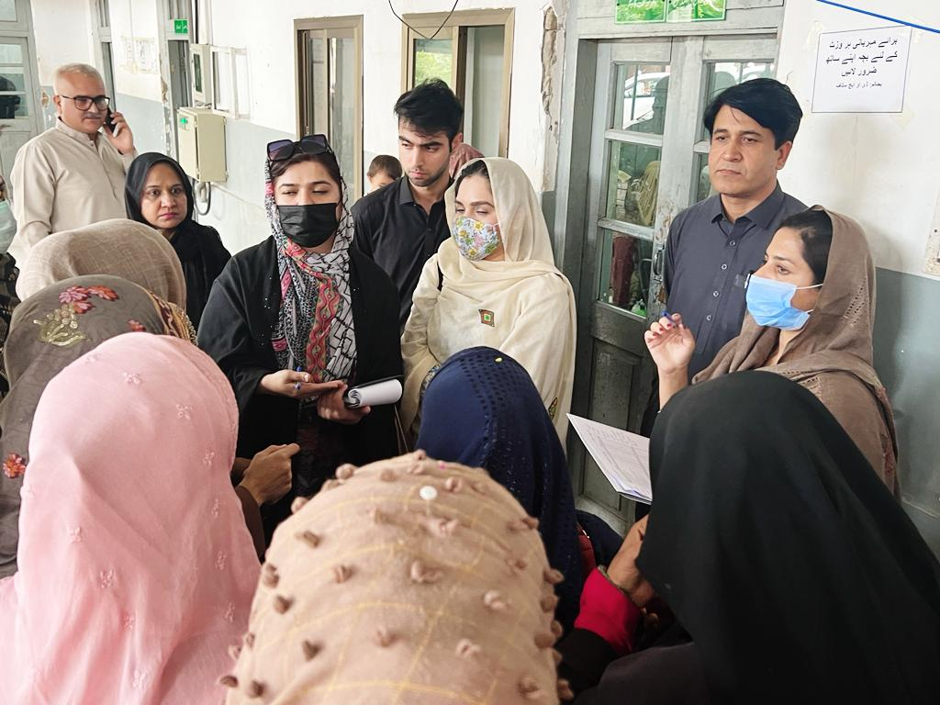 |  | 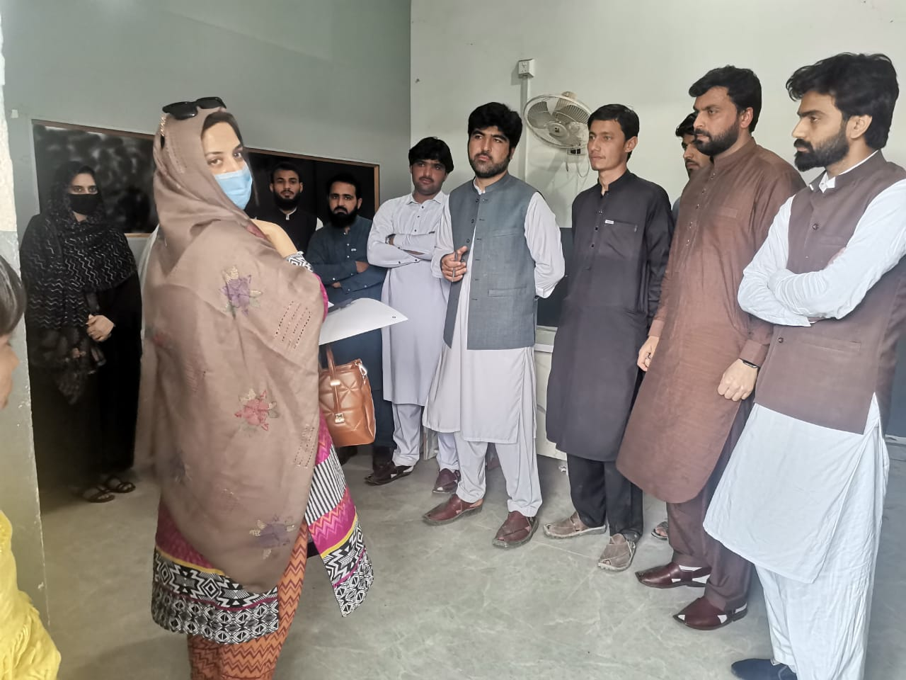
Consultation Meeting- Bannu-March 20, 2023
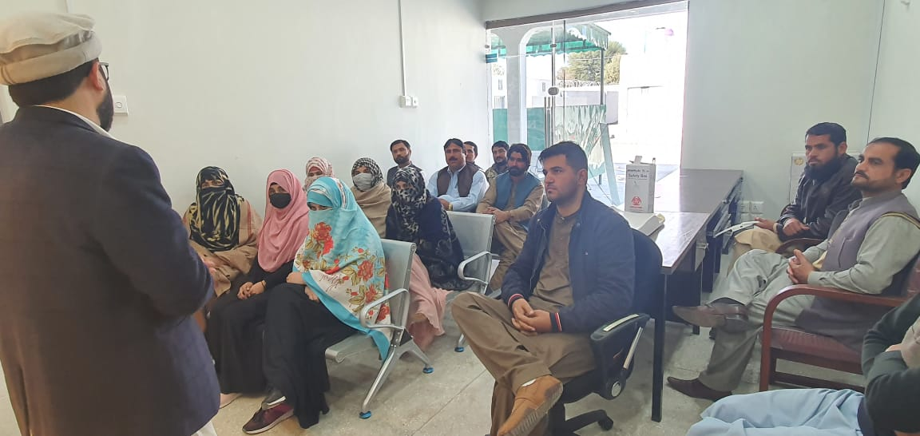 |  | 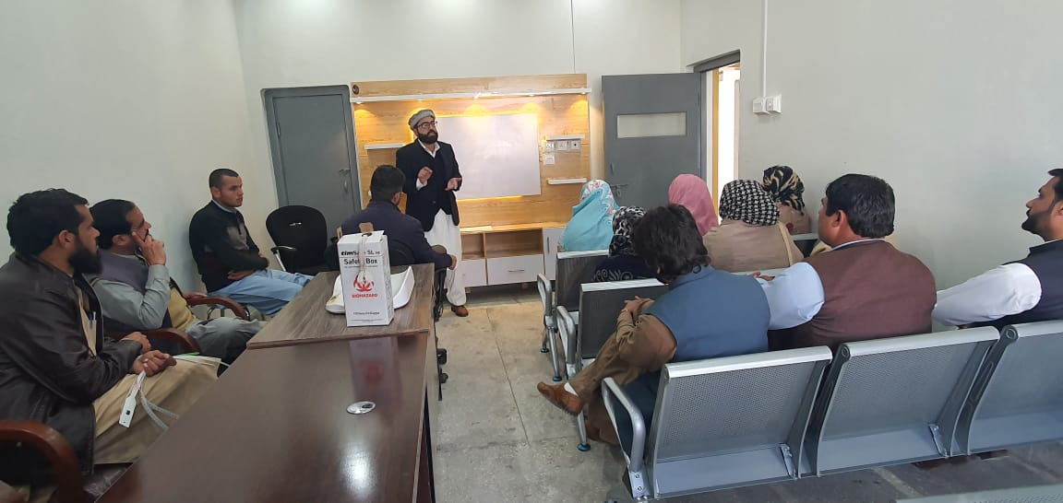
Consultation Meeting with CFC Staff- North Waziristan District, March 20, 2023
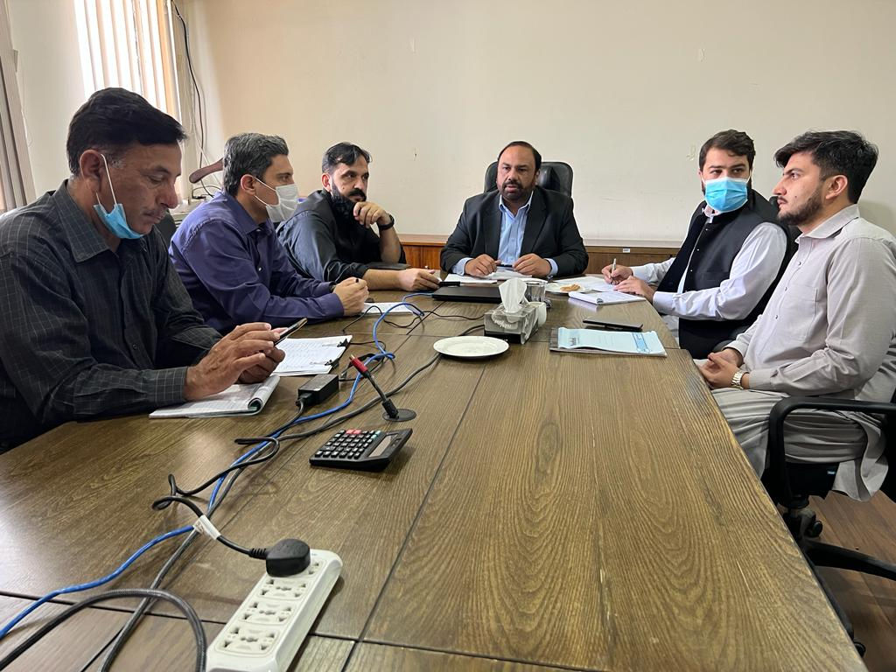
Consultation Meeting- Islamabad, March 20, 2023
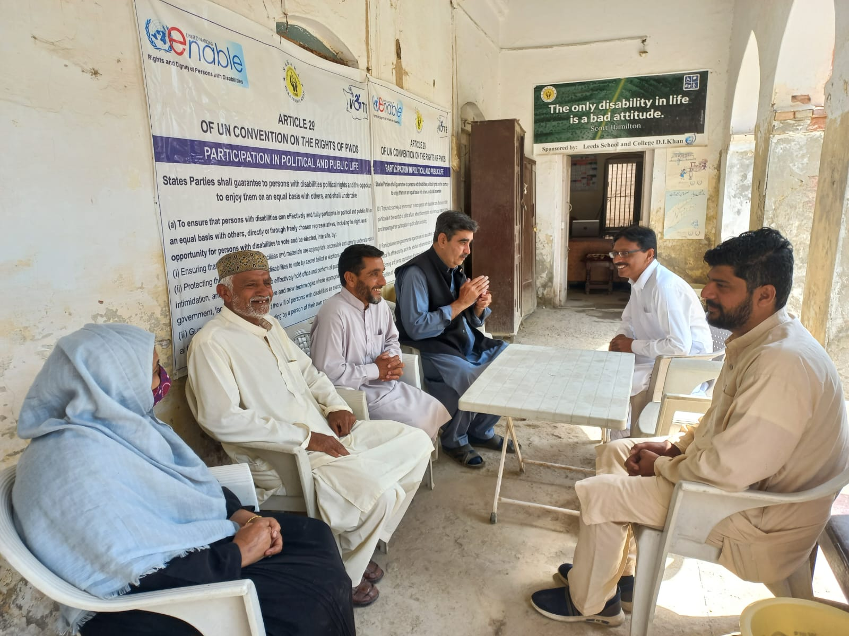 | 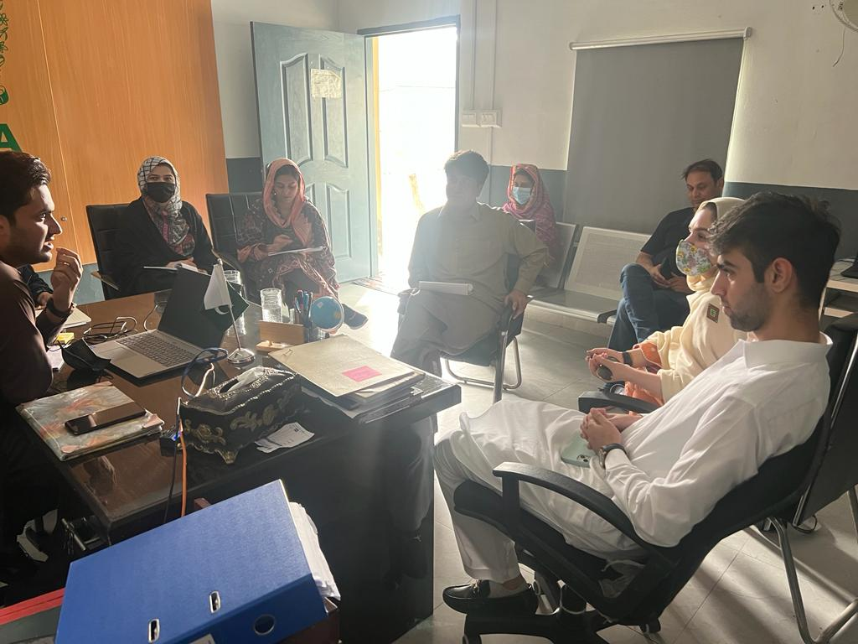
Consultation Meeting- Bannu-March 24, 2023
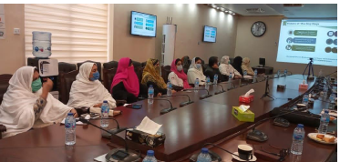 |  | 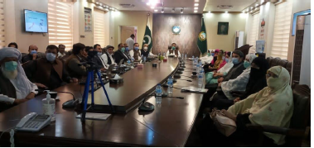
Consultation Meetings at DI Khan (04 Nov 2020)

ANNEX-2: LIST OF STAKEHOLDERS CONSULTED
Sr. No | Organization | Designation
NOVEMBER 2020
 | Politician | EX-MPA
 | District Health Department | Chairman (BoG)
 | Environmental Protection Agency | Operation Officer
 | District Administration | Additional Deputy Commissioner
 | Federal Ministry of Economic Affairs | Program Manager
 | NADRA | Project Manager
 | NADRA | Regional Director
 | Environmental Protection Agency | Director
 | Social Welfare Department, KP | District Officer
 | NADRA | Zonal AD
 | CEW-PDMA | GR Specialist
 | Department of Health | Health Coordinator
 | District Health Department | HoD
 | District Health Department | District Gynecologist
 | District Health Department | NADRA
 | District Health Department | LHV
 | District Health Department | LHV
 | District Health Department | LHV
 | NADRA | Zonal Officer, NADRA
 | MM Pakistan | District Coordinator
 | MM Pakistan | District Coordinator
MARCH 2023
 | PM | MEA
 | PM | NADRA
 | Ops. Coordination | MEA
 | L.O. | MEA
 | Health L.O. | Health Dept.
 | OIC Dogra | NADRA
 | MIS Officer | MEA
 | OIC | NADRA
 | Assistant Director | KP EPA
 | Focal Person- DoH for TDP ERP | Health Department
 | GR Specialist | PDMA KP
 | Assistant Director | NADRA
 | Social Mobilizer | Al Raees Foundation
 | Health coordinator | Sabawoon
 | Coordinator | Lasoona
 | Data Analyst | MEA PMU
 | Assistant Director | NADRA
 | Health Officer | Health Department
 | Coordinator | Sahara Foundation
 | LHV | Health Department
 | Mobilization officer | PDMA
 | Naib Tehsildar | District administration
 | Coordinator | Lasoona

Named as proposed Project in this document.
Two out of the three original components are part of the new project design: the CWG and the CFC. The Early Recovery Package which was an emergency related response linked to the TDP’s repatriation is not required as almost all displaced population has long resettled in their areas of origin.
Adapted from the “WB Stakeholder Analysis Guidance Note”
The project is already in implementation stage.
TDP-ERP- 12th ESMP- January-June 2022
The GRM is already disclosed at NADRA website for TDPERP Project and same will be utilized for this new proposed Project.

